4.7 Change of Variables in Multiple Integrals Worksheet

- Let R be the region bounded by the curves . Let and .
- Solve the equations for x as a function of u and v. Similarly, obtain y as a function of u and v. That is, determine .

If and we can see that this implies that. This means we are working with the transformation .

- Draw the region R in the u, v coordinate system.
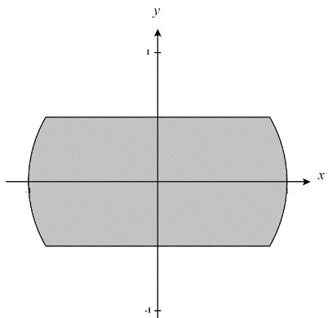
We first create a picture of the given region R (shown at the right).
We can define this region as
Our transformation implies a new region S. We see what T does to the boundary of R in order to determine S.

So, we see that based on our region R we need which implies that .

Also, we see that based on our region R we need which implies that
.
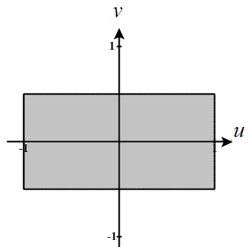
Also, we see that based on our region R we need which implies that
.

We can put this information together to establish that our region S has the following picture and can be defined as:

- What is ?

We see that .
So, .

- Use your answers from parts (a) – (c) to perform a change of variables on the double integral .

- The transformation takes the triangle with vertices to the region R as shown below. Evaluate area of R.
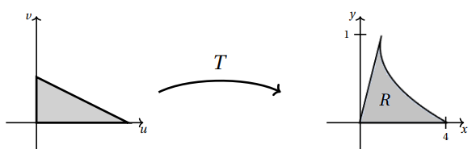

We know that where J represents the Jacobian of the transformation T.
So, if we are able to find the Jacobian of the transformation an integrate over our triangular region S we are good.
We note that the Jacobian of this transformation is .
We see that we can defined S by .
Therefore, we compute that

- Let T be the transformation given by . Let S be the triangle in the uv-plane whose vertices are . Let R be the region obtained when T transform S into a region in the xy-plane, that is .
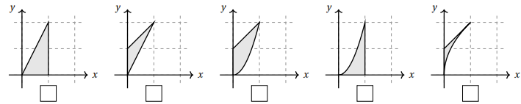
- Check the box below the picture which represents the region R (assume axes are scaled by 1s).

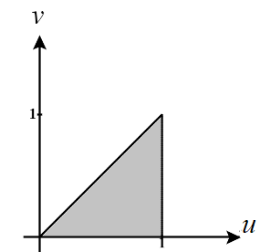
We know that the region S has the following shape in the uv-plane.
We see that T transforms the corner points of S in the following way.
, , and
We can see immediately that the 1st and 4th region do not contain the point and therefore cannot represent the region R.

We then check how this transformation changes sides of the region S.
S has the side where which implies that R has
Since the 2nd and 3rd regions don’t contain this boundary, they cannot represent the region R.

Therefore, we conclude that the 5th region must represent R.

- Express as an integral over S.
The Jacobian of this transformation is

- For each transformation T below circle “yes” or “no” depending on whether or not it takes the rectangular region S, in the uv-plane to the parallelogram region R in the xy-plane with vertices .
- YES NO |  | - YES NO
- YES NO |  | - YES NO
We first sketch a picture of each of our regions.
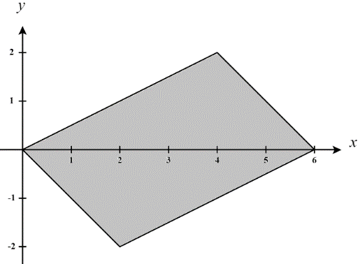
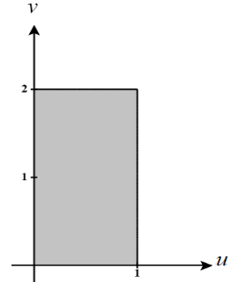

T

All transformations are linear here so we know that lines will be mapped to lines. Therefore, we can just see what each transformation does to the corner points of the region.

When transforming the point we see that:
From this we see that both are not correct transformations here.

When transforming the point we see that:

We can see that both produce the boundaries of R and therefore both are valid transformations here.

- Let R be the rectangle whose vertices are shown at the right.
- Exactly one of the following defines a transformation from the uv-plane to the xy-plane with , where . Circle the correct formula for .

First, we create pictures of each of these regions.
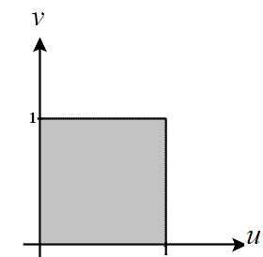
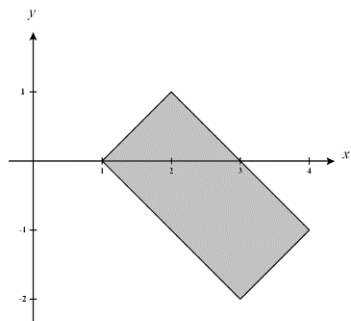

Second, we quickly look at what the transformation does with the corner points of the region S. We see that if we use the transformation our corner points become
, , , which correspond to the corner points of R. We also note that each other transformation maps at least one corner point of S to a point not in R.

- Determine if is negative, zero, or positive.

Based on our answer from part (a) our transformation is and the Jacobian of this transformation is

Therefore, we can re-express the given integral as
Thus, we have established that is negative.

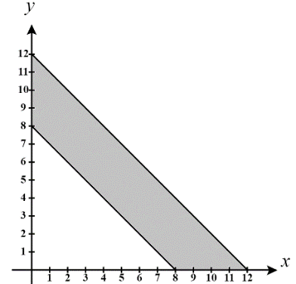
- Let E be the trapezoid with vertices . Using the change of variables change into an integral that is easier to evaluate. You do not need to evaluate the resulting integral.

We create a picture of the given region E (shown at the right).

If then, to solve for x and y in terms of u and v we calculate that
our transformation is and the Jacobian of this transformation is
T also implies a new region S which need to determine. Notice that all functions in our transformation are linear and so we know that all lines will map to lines. Therefore, we just need to see where the corners points of the region are mapped.

We see that :
We can put this information together to establish that our region S has the following picture and can be defined as:
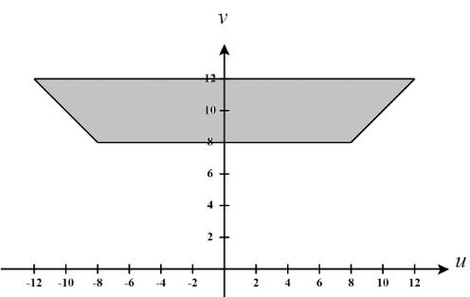

Therefore, we have
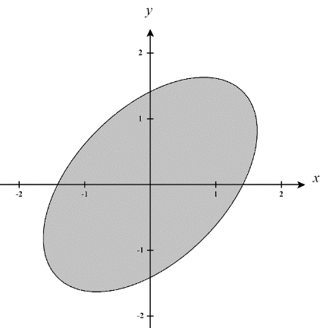
- Use the transformation to evaluate the integral , where R is the region bounded by the ellipse .

We create a picture of the given region R (shown at the right).

If then our transformation is and the Jacobian of this transformation is
T also implies a new region S which need to determine. We see what T does to the boundary of R in order to determine S.

This is actually very simple because we see that if the boundary is given by then this implies that
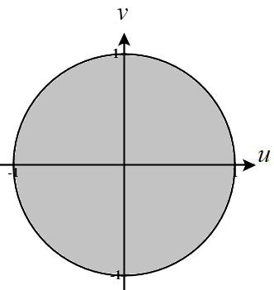
So, we clearly see that S is a circle of radius 1 and can be represented as
However, we know that this will be easier to integrate if we convert to polar coordinates after we have converted into terms of u and v. In this case we would redefine S as .

Therefore, we have

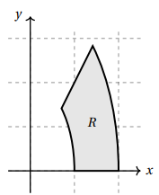
- Suppose R is the region in the first quadrant between the ellipses and and the lines and shown at the right. Using the transformation , find the integrand and limits of integration expressing the integral as an iterated integral over a subset S in the uv-plane with .

Our transformation is and the Jacobian of this transformation is
T also implies a new region S which need to determine. We see what T does to the boundary of R in order to determine S.

So, we see that based on our region R we need which implies that
. Many angle restrictions will make this true. We select to use .
Also, we see that based on our region R we need which implies that and then based on what we found in the previous lines since we know that for then this implies that
Also, we see that based on our region R we need which implies that
So, we see that based on our region R we need which implies that

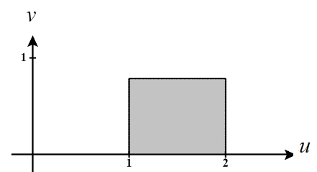
We can put this information together to establish that our region S has the following picture and can be defined as:

Therefore, we have
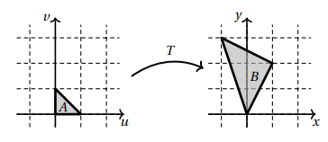
- Find a transformation T that transforms the triangular region with vertices to the triangular region B with vertices . As shown in the picture to the right.

We will try to create a transformation which maps , , and .

We can see that the transformation accomplishes this.

Since the transformation here is composed of linear functions, we know that lines will be mapped to lines. Therefore, we know that this transformation will work.

- Let T be the transformation . Let be the unit square in the uv-plan and let be the region that is the is the image of S under T.
- Check the box below that corresponds to the region R.

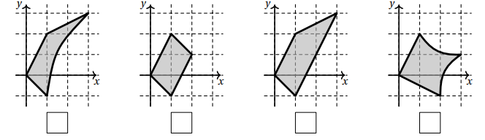

We start by just mapping some corner points to see if any options can be eliminated. We see that
.
From this we can eliminate options 2 & 4. We then see what the transformation does to a single edge of the given region S.

For where we have that . This implies where .

- Fill in the limits and integrand of the integral below so that it computes as an integral over the square S.

Therefore we have,
- Use an appropriate change of variables to evaluate the integral , where R is the rectangle with vertices .

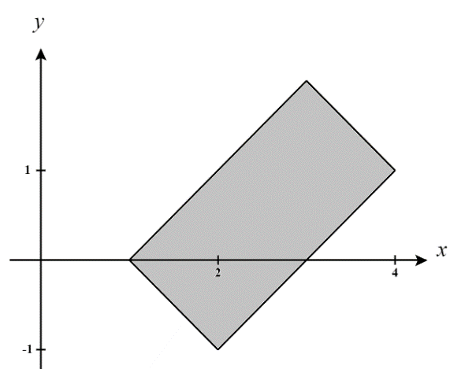
We create a picture of the given region R (shown at the right).

If then, to solve for x and y in terms of u and v we calculate that
Our transformation is and the Jacobian of this transformation is
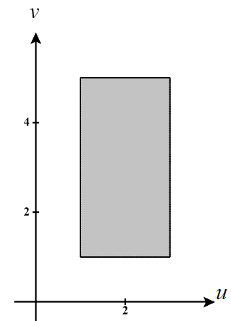
T also implies a new region S which need to determine. Notice that all functions in our transformation are linear and so we know that all lines will map to lines. Therefore, we just need to see where the corners points of the region are mapped.

We see that :
We can put this information together to establish that our region S has the following picture and can be defined as:

Therefore, we have
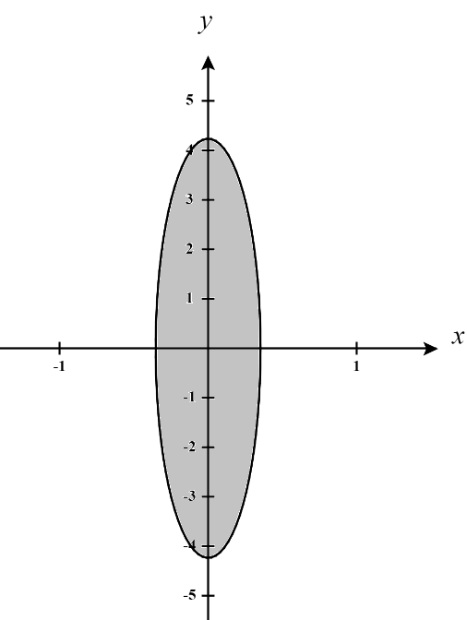
- Let E be the region bounded by . Find an appropriate change of variables and change into an integral that is easier to evaluate. You do not need to evaluate the resulting integral.

We create a picture of the given region R (shown at the right).

If we let then we can see that the boundary of our region will become

which will be extremely easy to integrate over.

Therefore, we will have the transformation and the Jacobian of this transformation is
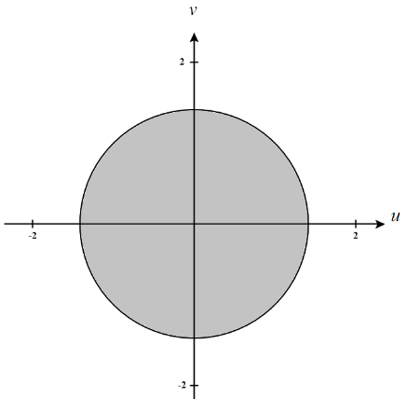
T, of course, implies the new region S which has the boundary and we can make this even easier to integrate if we convert to polar coordinates and represent S as

Therefore, we have

- Let R be a parallelogram with vertices . If , then compute .
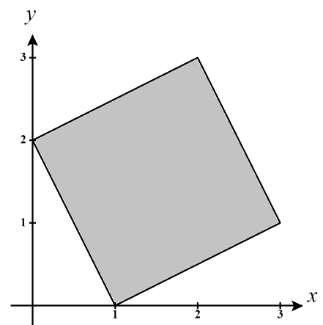
We create a picture of the given region R (shown at the right).
If then, to solve for x and y in terms of u and v we calculate that
Our transformation is and the Jacobian of this transformation is
T also implies a new region S which need to determine. Notice that all functions in our transformation are linear and so we know that all lines will map to lines. Therefore, we just need to see where the corners points of the region are mapped.
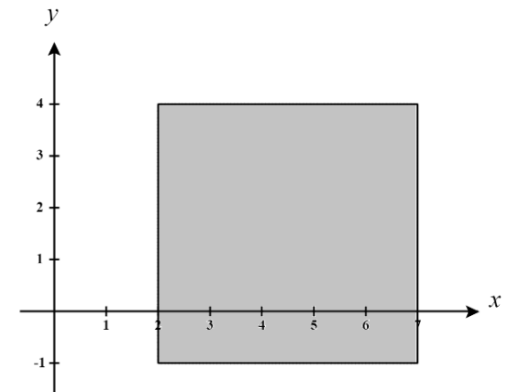
We see that :
We can put this information together to establish that our region S has the following picture and can be defined as:

Therefore, we have

